MIDTERM PROJECT REPORT

The Fizz Ware Brewing case:

Presented by: Rajiv Puli

Under the guidance of: Dr. Roger McHaney

Table of Contents
Visual #1….…………………………………………………………………………………………………………………... 3
Visual #2………………………………………………………………………………………………………………………. 4
Visual #3………………………………………………………………………………………………………………………. 5
Visual #4………………………………………………………………………………………………………………………. 6
Visual #5………………………………………………………………………………………………………………………. 7
Visual #6…………………………………………………………………………………………………………………… 8
Visual #7…………………………………………………………………………………………………………………….. 9
Visual #8…………………………………………………………………………………………………………………….. 10
Visual #9-1…………………………………………………………………………………………………………………….. 11
Visual #9-2…………………………………………………………………………………………………………………….. 12
Visual #10……………………………………………………………………………………………………………………….. 14
Visual #10-2………………………………………………………………………………………………………………………..15
Essay #1……………………………………………………………………………………………………………………… 17
Essay #2……………………………………………………………………………………………………………………… 22

Starting from the year 1987 we have the complaints. The displayed visual is of only from three departments which are Brewery, Customer Service and Recruitment. Only these departments are mentioned to display the information clearly and the number of complaints are more within these departments. The number of complaints significantly increased in the years 2020 and 2021 for these three departments.

These are top 10 cities which have more number absent hours and complaints. So, Vancouver tops the list with 12,052 absent hours and 237 number of complaints. We can see other cities such as Victoria, New Westminster and Surrey which are having more number of absent hours and complaints.

We can see the list of top offenders in this list. Chris Camp has more number of complaints than anyone else. Followed by Francis Hamlin and others. We can also see that the complaint class for top offenders are Harassment, Major and Minor.

Here is the data showing the number of offenders by complaint class and gender. We can see that there is no significant difference between the Female and Male number of complaints by complaint class. Also we can see that there are more number of Major, minor, drug and harassment, bullying etc. complaints on both male and females.

This is the representation of complaint class by departments. The Brewery, Customer service and recruitment are having more number of complaint classes within their departments.

This is representation of number of absent hours with each departments. We can see that the brewery, customer service and recruitment departments have the more number of absent hours.

These are the most troubled employees according to calculation created by me. The formula I used is:

﻿[Communication Skill] < 5 AND [Independence] < 5 AND [Self Control] < 5 AND [Work Anxiety] > 7.

I set this criteria to identify the employees who are having less skills such as communication, independence and self-control. Also used to find employees with more work anxiety.

All these skills are important for an employee and the work anxiety should be less. By using my formula I wanted to filter out the employees who are having less skills and complaints on them.

So, the most troubled employee is Justin Jackson with 7 complaints which are major. Other employees are also having complaints for different complaint classes.

This criteria is to know only the employees with less skills and complaints on them. This does not justify according to more number of complaints. People with more skills could have more complaints on them. But, this is to just identify the employees who are having less skills and complaint count on them.

Scatter plots depicting absence time by employee versus number of complaints against them, work anxiety, innovation and independence.

So, this is the visualization depicting each department count of complaints. The Brewery department consists of highest number of complaints with 428. The customer service department consists of 234 complaints and recruitment departments is with 91 complaints.

So, the most troubled departments are Brewery, Customer Service and Recruitment.

Just focusing on the most troubled departments.

In my opinion, the most troubled departments are Brewery, Customer Service and Recruitment.

These departments need managerial intervention. Let us look into each department individually and analyze it.

Brewery: Since the brewery department has more number of complaints we can understand that the Fizz Ware is a brewing company. So, one of the main department is brewing in the company. From this I assume that there will more number of employees who work in this department. Obviously when more number of employees work in a department can consists of more number complaints. There are total 428 complaints in the brewery department. But there are 93 major complaints. Which is 21% of the whole complaints. This department needs the management intervention to take strict measures to avoid or prevent their employees from making mistakes.

Customer Care: The customer care is also one of the most important department. To run a company successfully it is very important that the customer service should be efficient. So, this department consists of total 234 complaints. This department consists of 67 major complaints that is 28.63%. This is huge and immediate intervention of management is required.

Recruitment: The recruitment department is also one of the important department for a company. A part of companies success depends on the kind of staff they recruit. So, this department consists of 91 complaints. The major complaints percent is 30% which is lot more than the other two departments.

According to major complaint percentage among these three departments the most troubled departments are ranked as follows:
- Recruitment
- Customer care
- Brewery

For any company to be successful it is important to prevent their employees from making mistakes. Also if any employees make mistakes they should resolve the complaints on them by taking necessary strict action to not repeat those mistakes or to suspend them.

This visualization consists of the departments with number of unresolved and pending complaints. We can see that the Brewery department has the more number of unresolved complaints followed by Customer Service and Recruitment.

So, let’s look into the departments with highest number of unresolved and pending complaints.

Brewery: The brewery consists of highest number of unresolved complaints. There are 205 unresolved and 8 pending complaints. So, when we calculate this is 48% of total complaints for this department. This means nearly half of the complaints in brewery department went unresolved. This is so bad for a company. This requires immediate action to resolve these complaints by the management.

Customer Service: The customer service consists of second highest number of unresolved complaints. There are 101 unresolved and 2 pending complaints. So, when we calculate, this is 43% of total complaints for this department.

Recruitment: The customer service consists of third highest number of unresolved complaints. There are 34 unresolved and 10 pending complaints. So, when we calculate, this is 35% of total complaints for this department.

According to unresolved complaint percentage among these three departments, the most troubled departments are ranked as follows:

- Brewery
- Customer service
- Recruitment

It is very important to resolve the complaints time to time. Accumulation of complaints will lead to unpleasant environment among the employees. This will impact the performance of the employees thus leading to downfall of the company.

Essay Questions

1.
Subject: The Fizz Ware Story

Background:

Fizz Ware a brewing company which is located at Canada. It consists of multiple departments present in the company.
- Generally we use so many different products in daily life.
- As a consumer we just focus on what we need and will buy a product which we like.
- But, do we know how much efforts does a company and its employees work to produce a single product?
- To run a company successfully it mainly depends on their employees.

Problems to be answered:

- What if some of the employees cause disturbances for the company?
- How should a company deal with the employees who causes different problems for the company and their co-workers?
- Of course we can’t expect every employee to not make mistakes. But, how much it impacts the company and their co-workers is important.

Let us find out the answers for all of these questions:

So, we trying to find out the impact a company can face due to employee mistakes and let us understand why is this happening.

So, the complaints are the disturbances.

Let’s go step by step:

Let us look into the complaints registered for each department employees for the company:
So, this is the data which consists of the different departments and the number of complaints registered for the each department.
We can say that the Brewery, Customer Service and Recruitment are the departments which are facing most number of complaints.
Why does the brewing department has more number of complaints than any other departments?
Since this is a brewing company department has more number of complaints we can understand that the brewing is one of the largest department.
More number of people working in a department can lead to more number of complaints as well.
We can say that these are the most troubled departments.

We can see these are the most troubled departments with different classes of complaints. We can see different complaint classes here.
All these kinds of complaint classes will lead to disturbance in working environment. The co-workers will get affected which can lead to decrease in their work performance.

These are unresolved complaints in each department.
The more number of unresolved complaints will lead to more problems. It is important to resolve the complaints time to time.

Resolution:
Let us look how can companies deal with these kind of disturbances caused by certain employees:
- Companies management should take time to resolve the complaints time to time. This is very important since the harmony of the workspace can be affected if resolution takes time.

- The management should concentrate on the most troubled departments and should investigate the cause for more complaints. Should take necessary actions after knowing the cause of complaints.

- To prevent criminal, mental or physical attack complaints it is better to perform background check on all the employees are when they are being recruited.

- They should create an effective disciplinary policy.

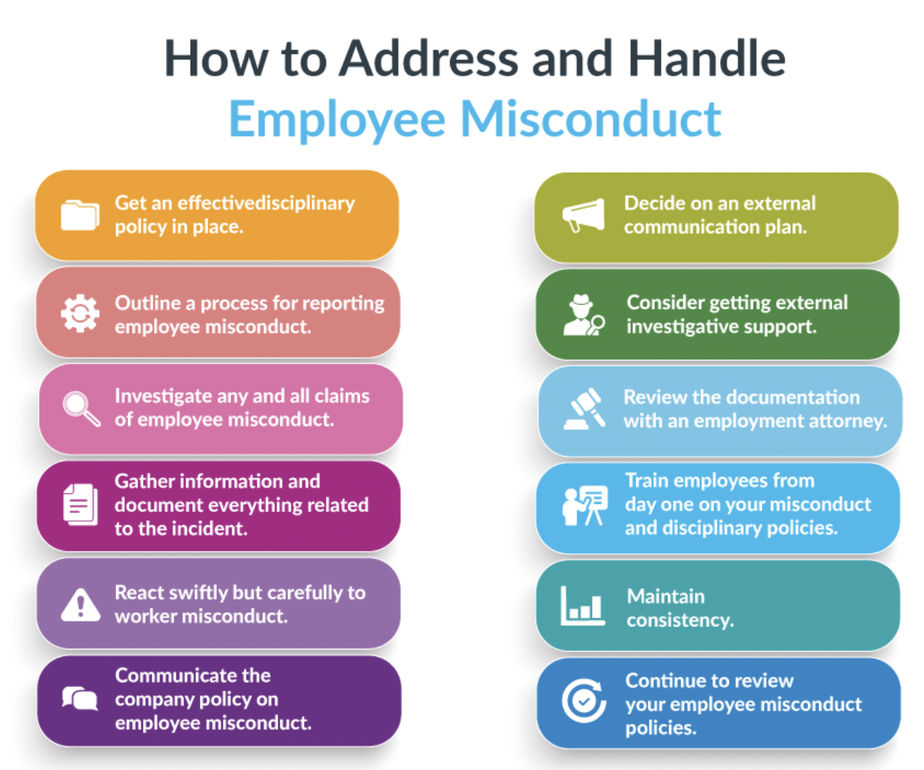

Reference: https://www.aihr.com/blog/employee-misconduct/
This above picture is obtained from internet. The reference is mentioned above.

2.

Story Telling

How does complaints and absenteeism are different per department and city?

So, we can see that Vancouver has the highest count of complaints and as well as the absent hours.

From the visualization we can understand that the number of complaints is directly proportional to absent hours.

This means when there is increase in absent hours across cities there is also increase in number of complaints.

Why would the city like Vancouver has more number of complaints and absent hours?

This would be more number of employees working in that city. As we know Vancouver is a big city and has much more population. So, the number of people working in Vancouver branch would be high.

Why is absent hours is directly proportional to count of complaints?

Since the number of employees who are facing complaints against them or the employees who complained will not be interested to attend the office. We know that the number of unresolved cases in data are very high. In most troubled departments it is nearly 50%. So, what we can understand that due to not resolving the complaints properly, the number of employees who are facing complaints against them or the employees who complained will not be interested to attend the office. This is would be one of the reason.

Conclusion: When the count of complaints increases the number of absent hours is also increases.

